|  |
| --- |
| LockedMe.com  (Application Screenshots) |

*Version History*

|  |  |
| --- | --- |
| Application Name | LockedMe.com |
| Developer Name | Hrishikesh Avhad |
| Purpose | To view code outputs on various user inputs |
| Product Version | 1.0 |

Contents :

**1.Main-Menu**

**2.Code output screenshots**

Main-Menu

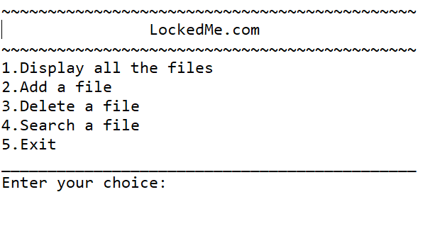

//To Display all files

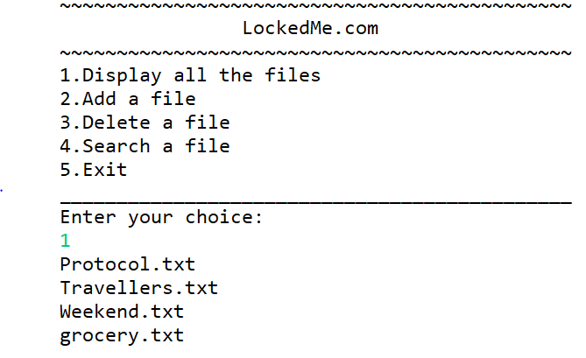

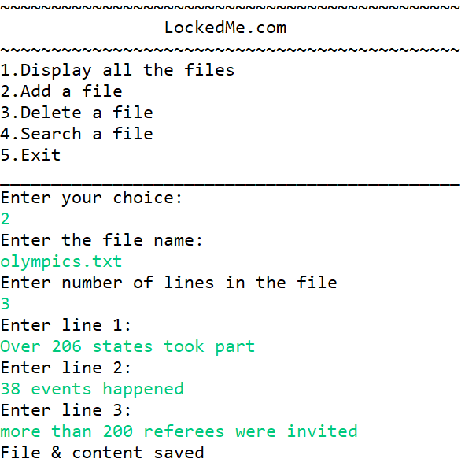

// To Add a file (Above code)

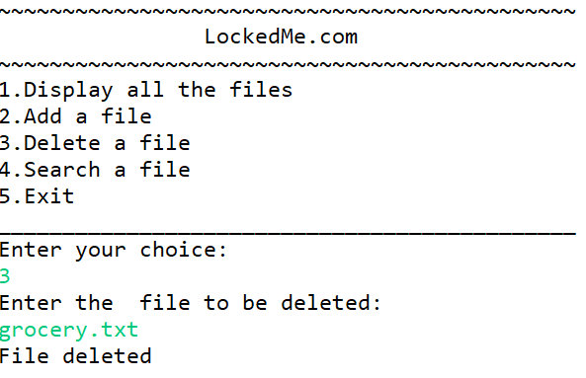

//To delete a file

//If file not found or could not fetch file

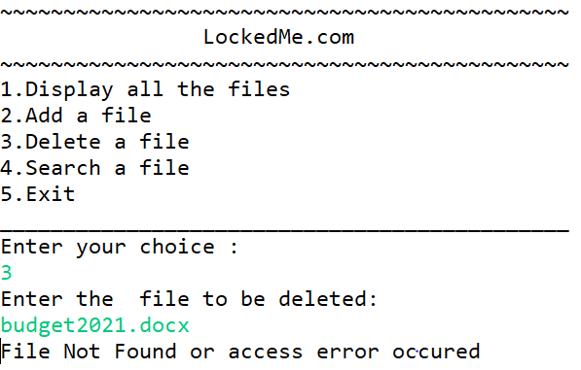

*//To Search a file*

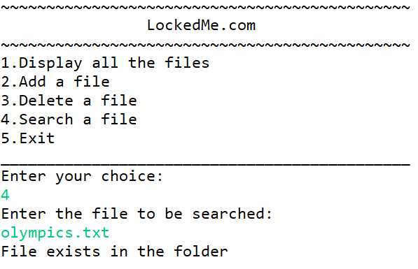

//If file is not there in the folder

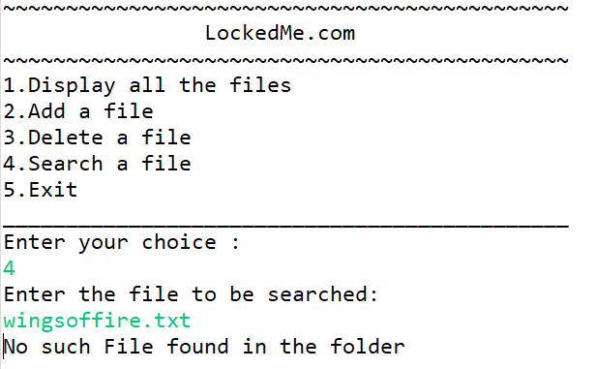

//To Exit from the Menu

